Introduction
In this lab manual, we shall work together to learn and implement new concepts including setting up a GitHub Account and using GitBash to remotely store your files.

Skills to be learned:
- Creating a GitHub account and Installing GitBash to remotely store the files
- Adding, Committing, and Pushing files remotely to the GitHub repositories

Let's do some coding.
First Thing First, Let's create a Github Account.

Go to https://github.com/ and Click on Sign Up Button | 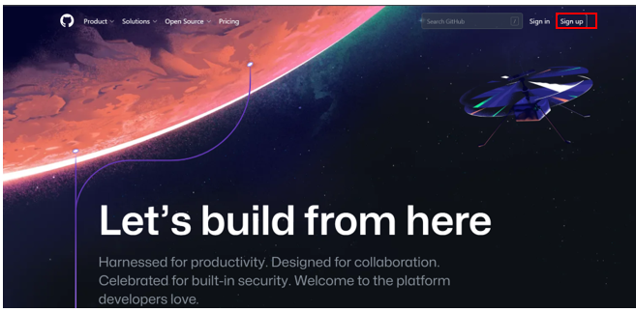
You will need an email account for creating your GitHub account.  Enter the email address of your account.  Choose a password and complete the profile.  Note: In case you already have a GitHub Account, just sign in using that account. | 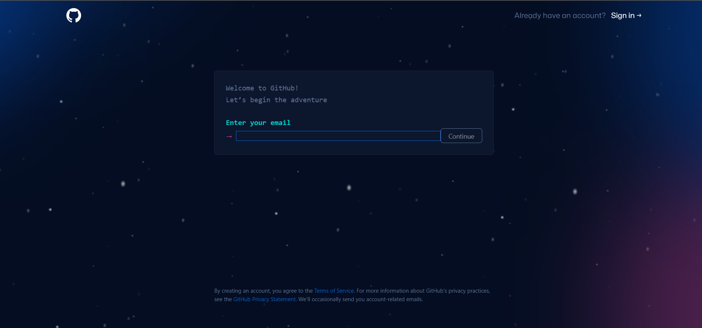
After that you will be asked to verify that you are a human | 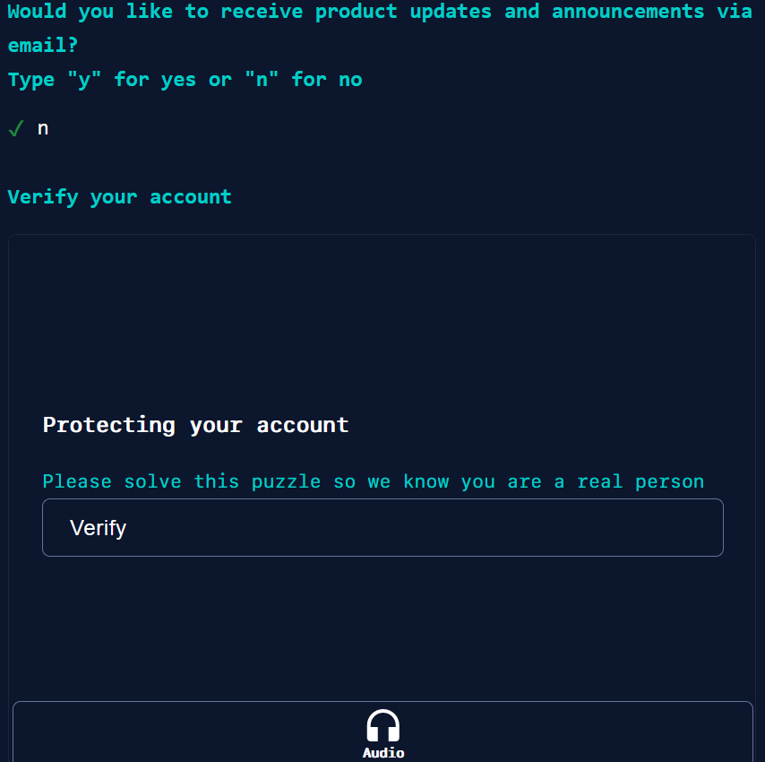
After successful Verification, you will be given the launch code on your email that you chose to create a Github account with.  See your email and enter the launch code. | 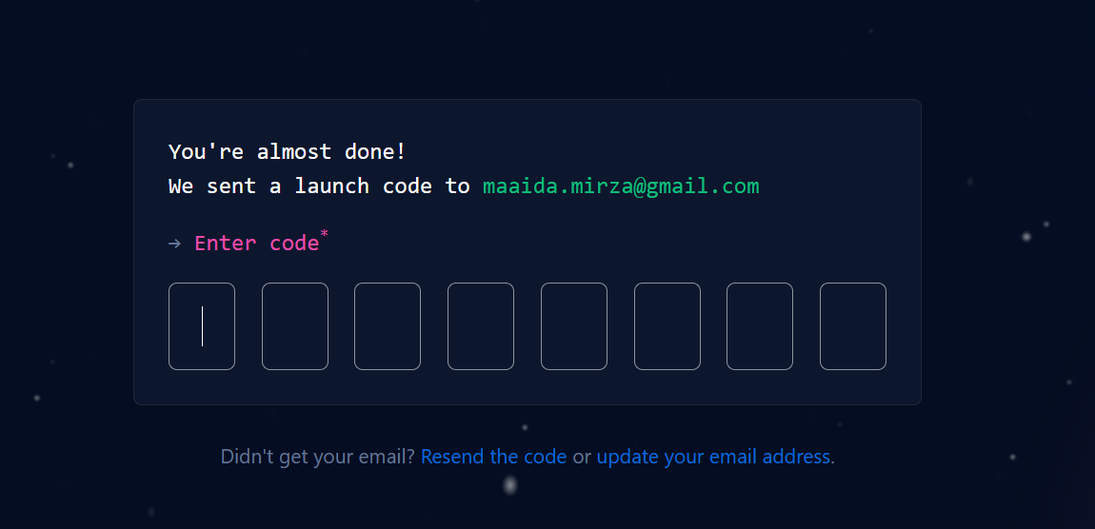
You will be asked to enter some information related to you  Question: How many team members are working with you?  Choose 2-5  Question: Are you a teacher or student?  Choose Student | 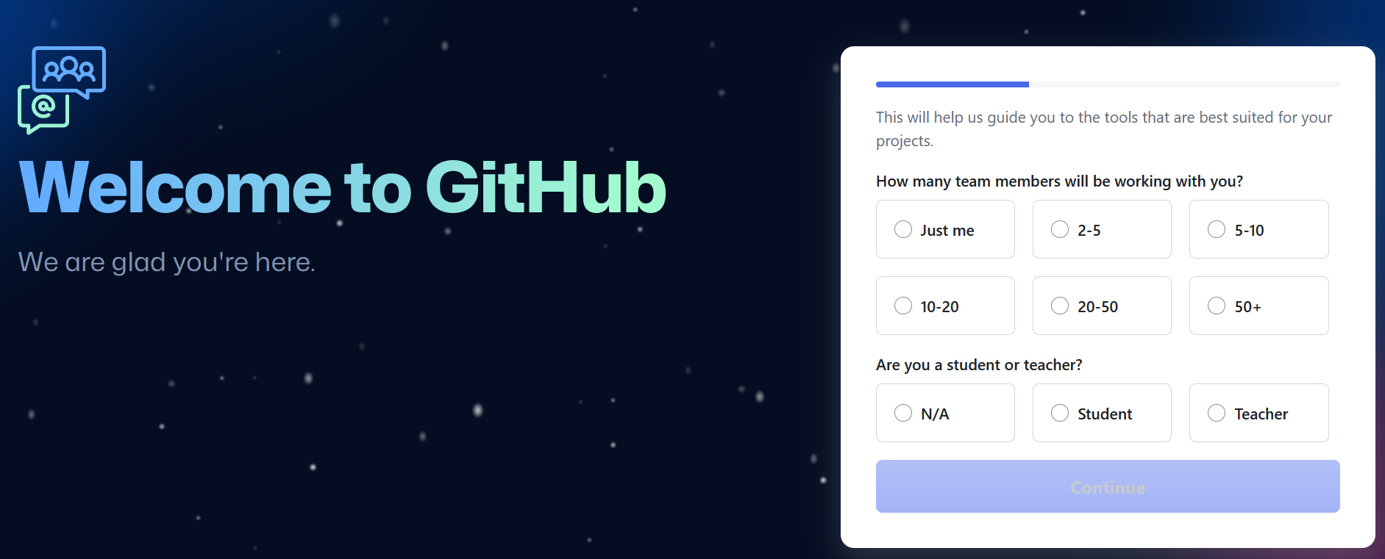
You will be asked to choose the features you are interested in.  Choose Collaborative Coding and and project management | 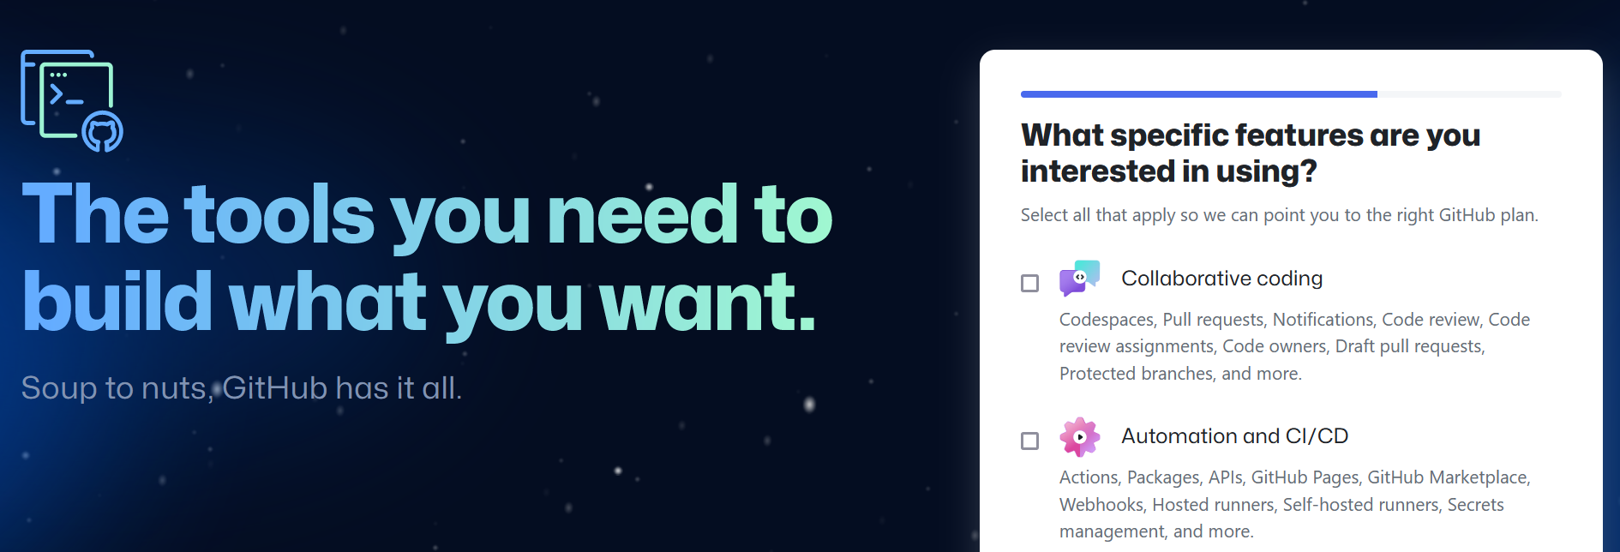
Then you will be asked to choose which version you want to use  Choose Continue for Free | 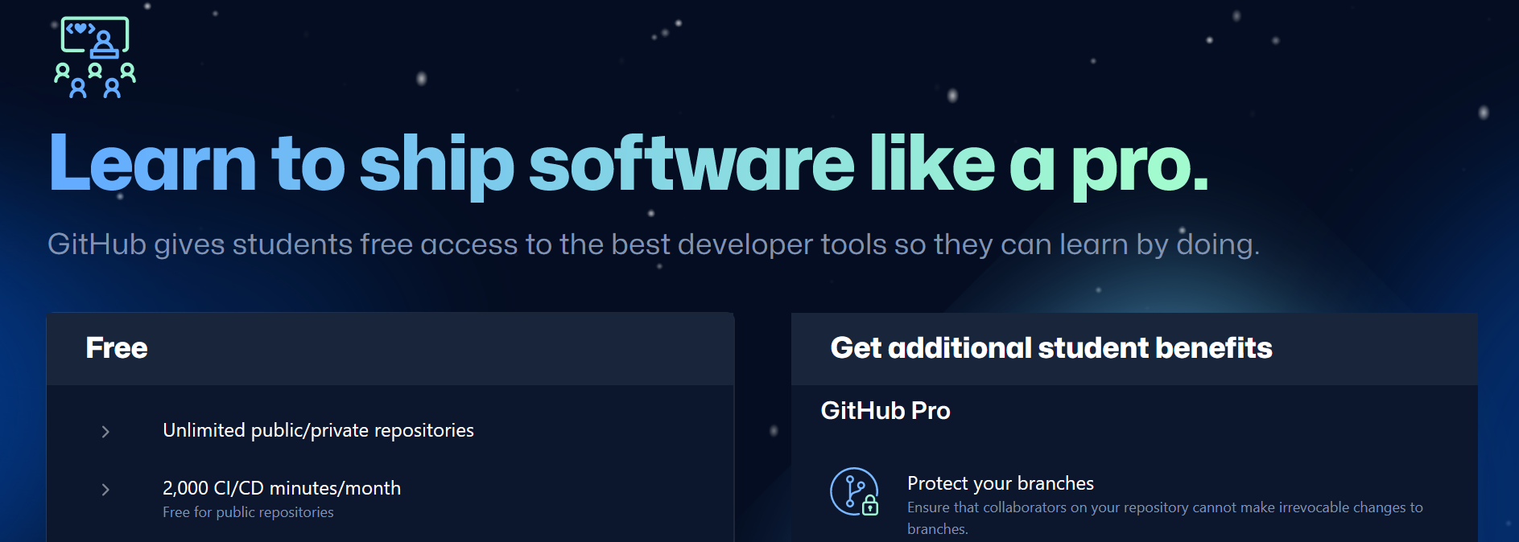
Welcome to your GitHub Account. | 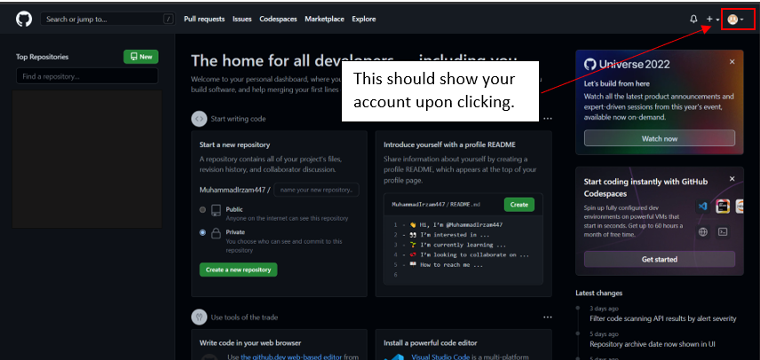
Now Let’s Install GitBash.  Visit  https://git-scm.com/download/  To download GitBash which will be used for uploading files to your git account. | 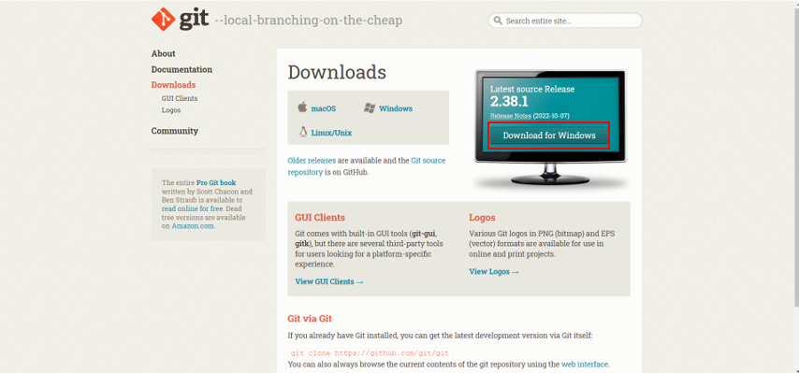
Install the Latest 64bit Setup for Windows. | 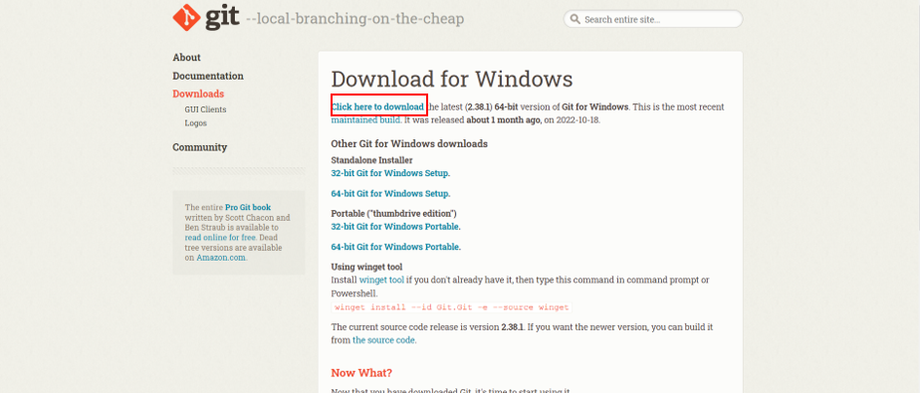
Sit tight, it may take a minute to complete the download.  Upon successful completion, Double Click on the downloaded file and choose Run from the menu. | 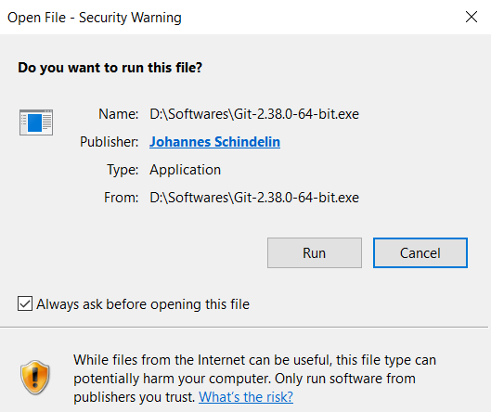
Choose Next | 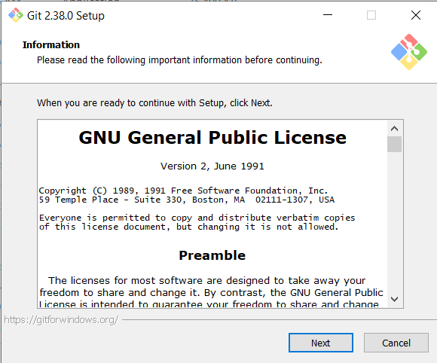
Choose Next | 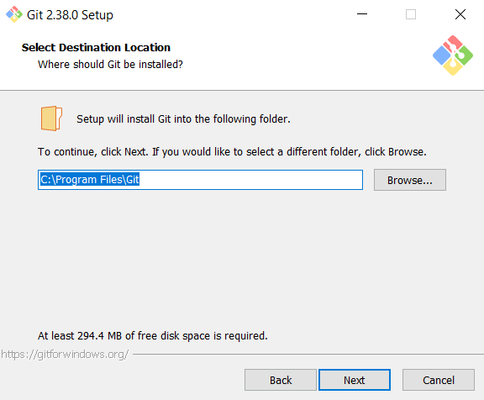
Choose Next | 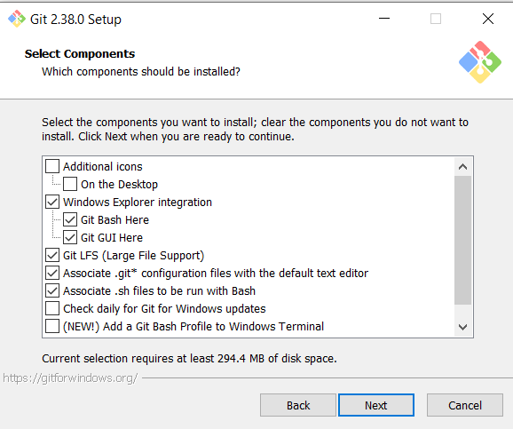
Choose Next | 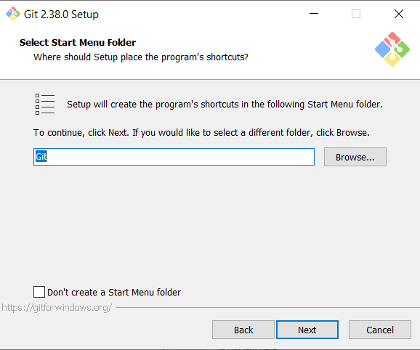
Choose Next | 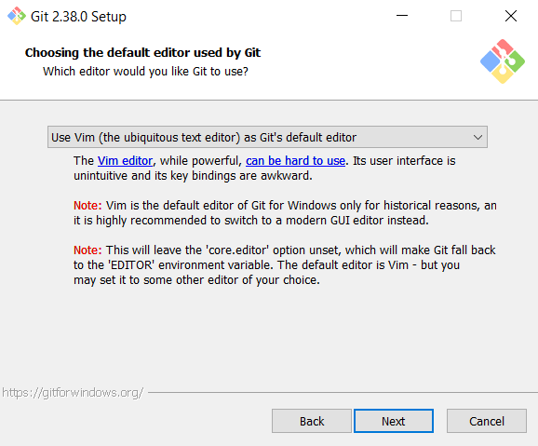
Select Let Git decide and Choose Next | 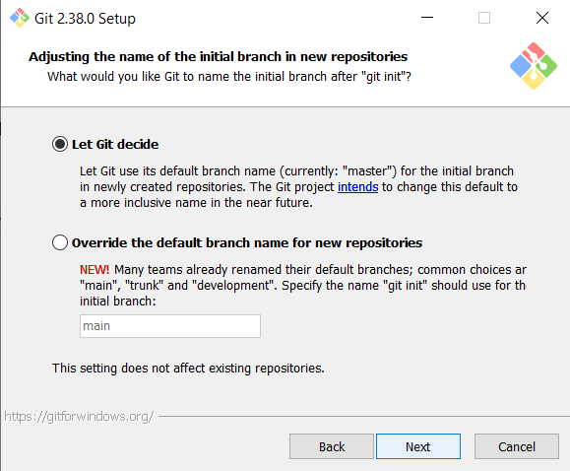
Choose Next | 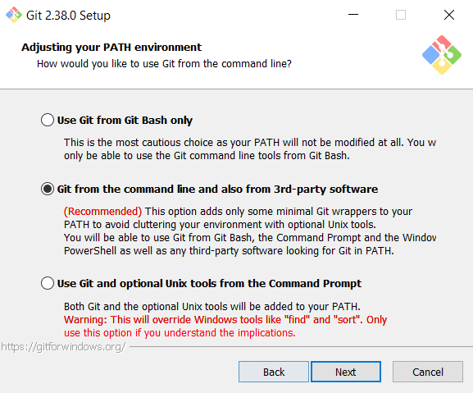
Choose Next | 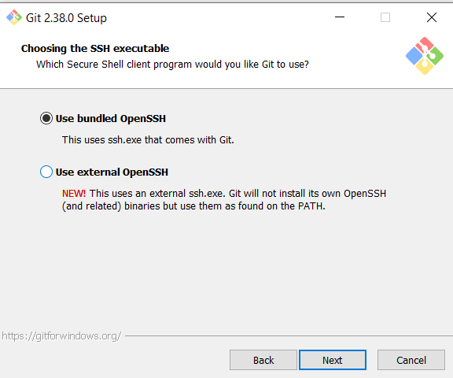
Choose Next | 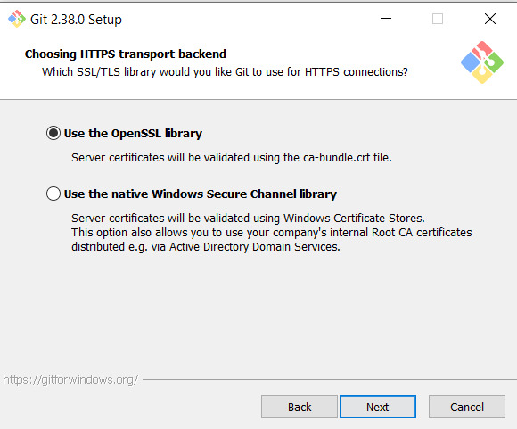
Choose Next | 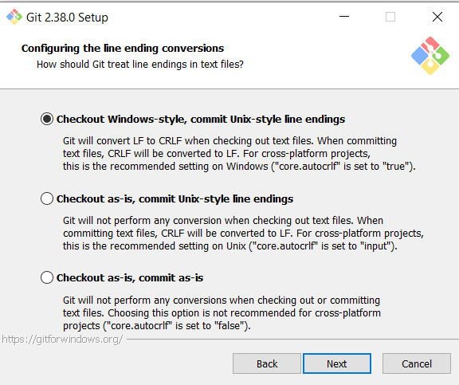
Choose Next | 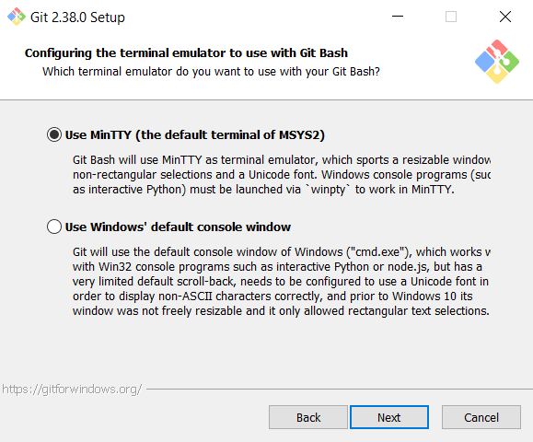
Choose Next | 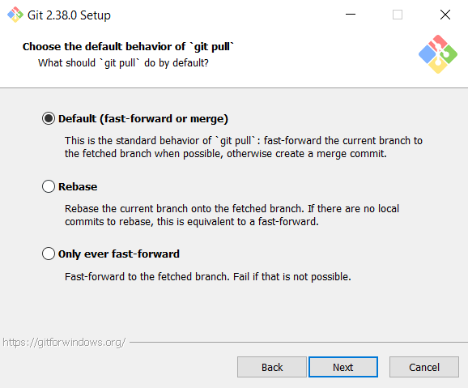
Choose Next | 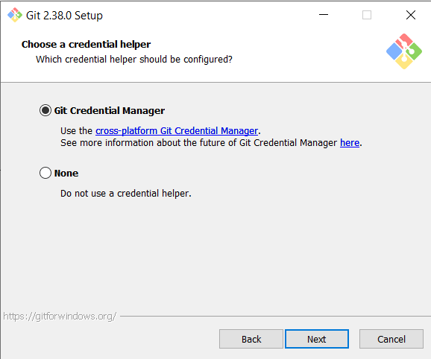
Choose Next | 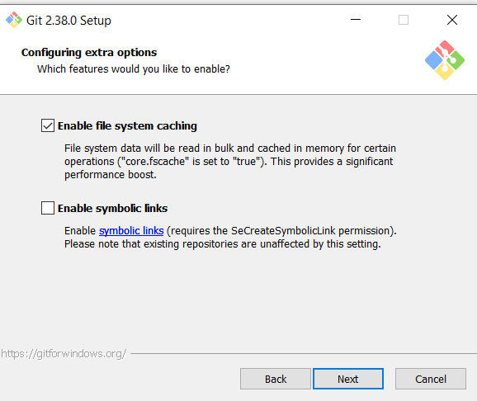
Choose Next | 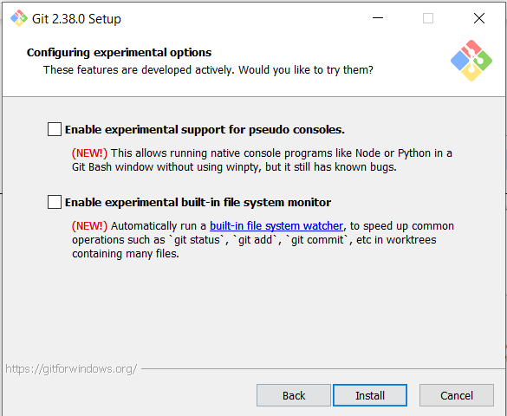
Please Wait for the setup to install. | 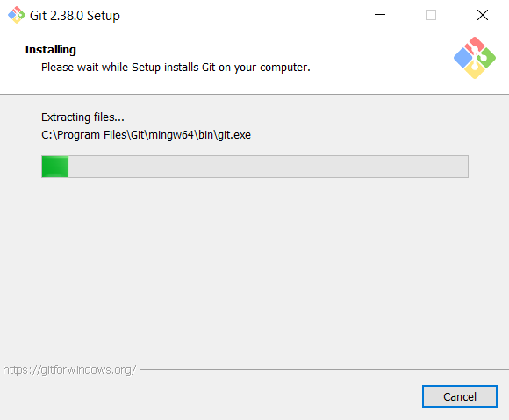
Choose Finish | 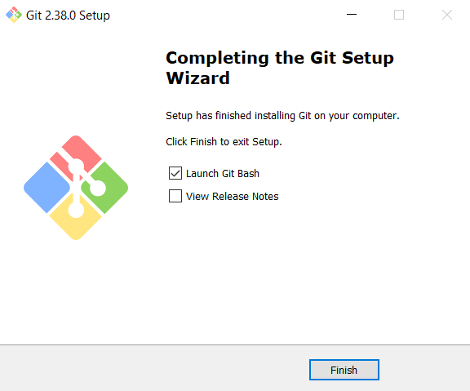
GitBash cmd should appear on your screen upon successful completion. | 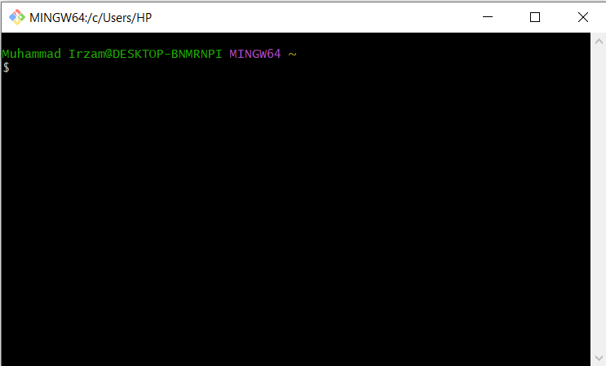
In order to open gitBash in a specific directory, right click on any empty/white space and choose Git Bash Here | 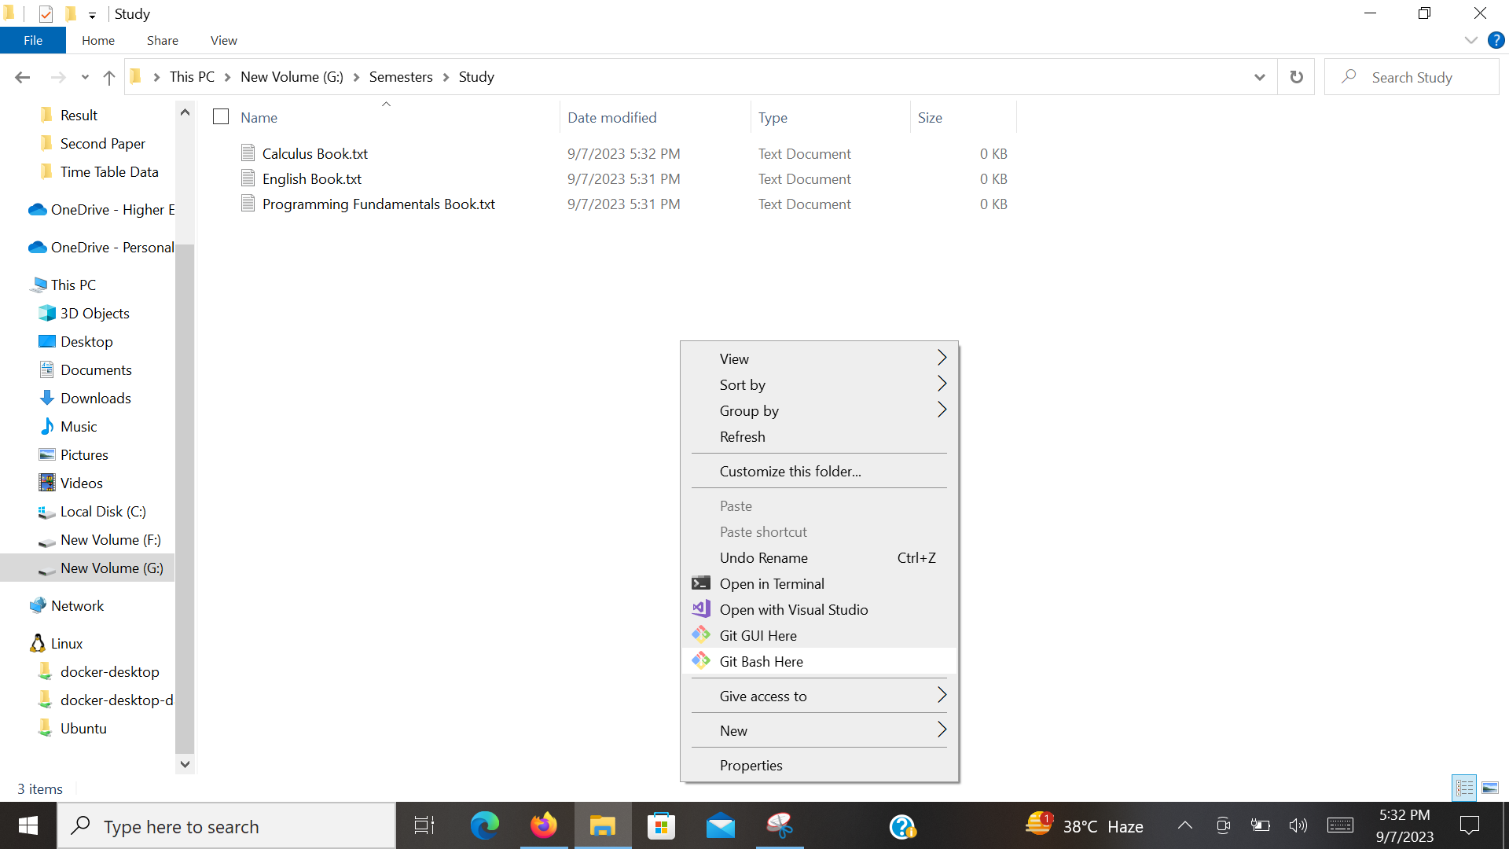
Great work. You have successfully installed GitBash.
Now, Let’s get back and Configure the GitBash so it will be connected to your GitHub Account.
Navigate to the folder where you have stored your codes and Right Click in the window and choose GitBash here. | 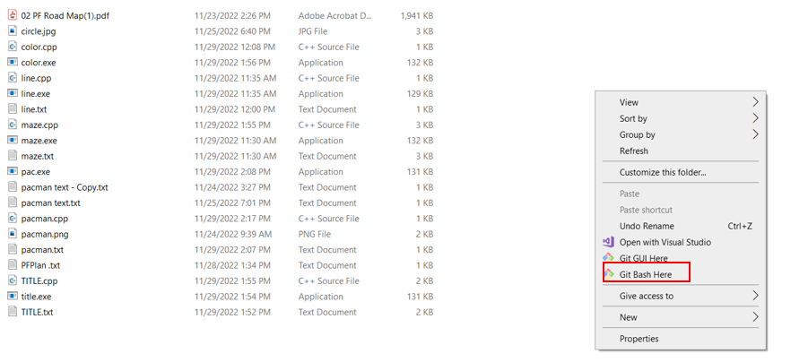
It will open the GitBash cmd in that directory
Write the following command in the cmd.

git config --global user.name "yourGithubUserName"

Replace the username with your own GitHub username.
Here is a working example:
Write the following command in the cmd.  git config --global user.email "yourEmailAccount”  Replace the email account with your own email account that you are using for GitHub. Here is a working example: | 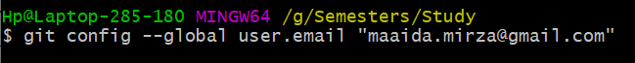
Note: These commands are a one-time task only and all the remaining steps are repeated for each new directory(folder) that you want to upload to your GitHub account.
git init

Execute this command, to start your session.

Note: The good thing is you need to execute this command only once to start your session in a specific directory.
git add .  This command is used to add all the files that are in your current working repository. | 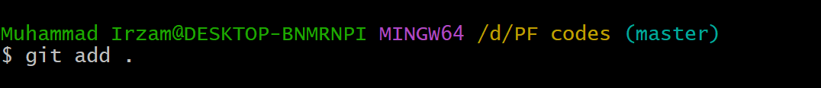
git commit -m “message”  This command is used to make a commit (time stamp record of your file and changes in that) in your Git repository.  NOTE:  Now, do not close this window and go to the web browser. | 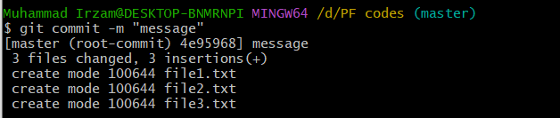
Now go to your GitHub Account(www.github.com/) and create a Repository.  Look at the attached screen to create a repo. | 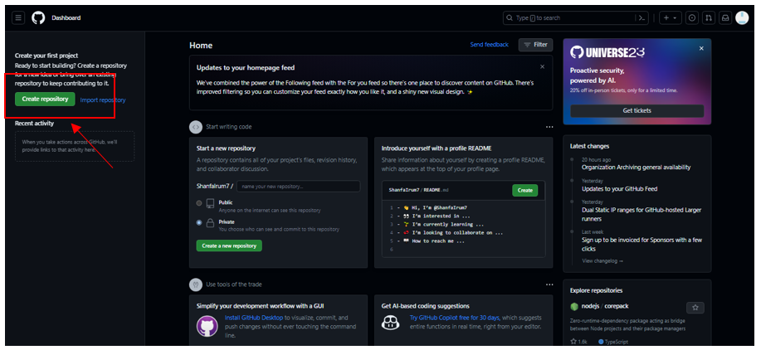
Give it a Name and Provide a description.  A Public Repository is accessed by anyone on the internet.  A Private Repository can only be accessed by you.  For now, choose Private and click on Create Repository. | 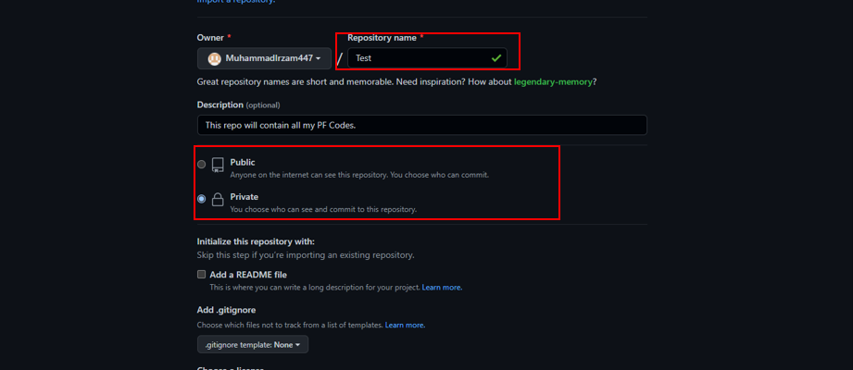
On Successful creation, the attached screen should appear. | 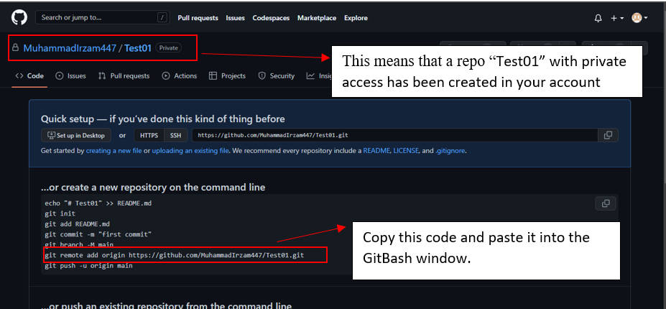
Maybe some get the following screen. | 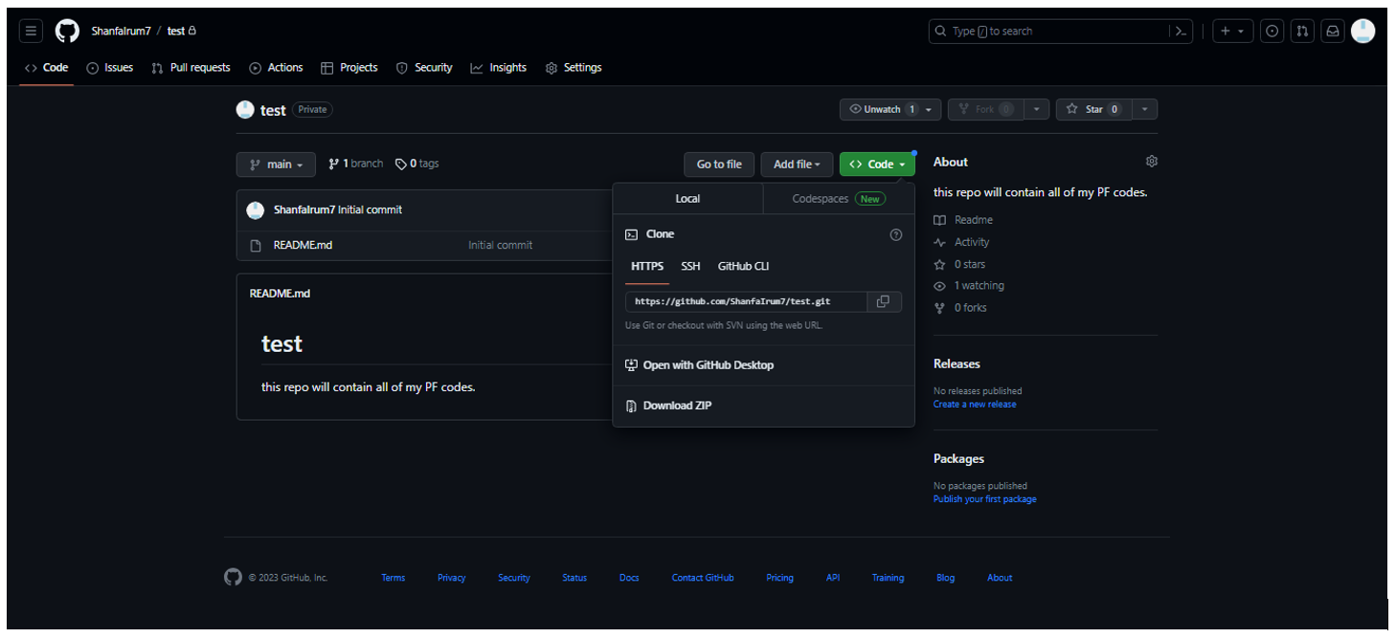
Now, switch back to GitBash and right click in the GitBash Window and Click on the Paste option and Hit Enter.

The command should look like this:
git remote add origin https://
Now, upload the files to the remote repo using the following command.  git push -u origin master  This command is used to upload all the committed files to your remote repository. | 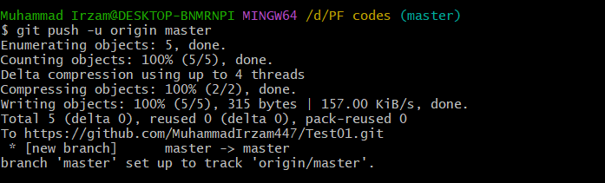
Congratulations, you have created your GitHub Account and used GitBash to Upload the files to the remote repository.  You can check that by visiting your GitHub account and choosing your created repo. | 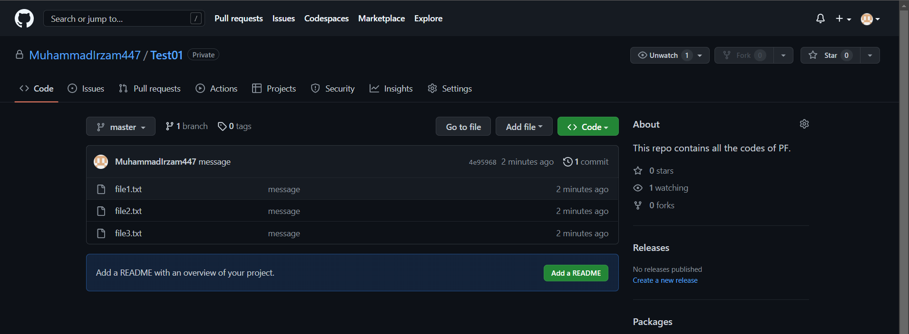
Congratulations, you have successfully created your GitHub account and uploaded all the files in the PF Codes folder. Great Work Guys! You have just added another skill to your skill set.

Conclusion
Lets explain why uploading files to a GitHub account is beneficial:
Backup and Security:
Uploading your work to GitHub serves as a backup. Computers can crash, and files can get lost. By keeping your code on GitHub, it's safe and accessible from anywhere with an internet connection. Your work is secure even if something goes wrong with your local machine.
Showcasing Your Work:
GitHub is not only a tool for development but also a platform to showcase your skills to your TAs as well as to your juniors in the future. By sharing your projects on GitHub, you create a portfolio of your work. This can be a significant asset when applying for internships or jobs in the tech industry. Industry Employers often look at GitHub profiles to assess a candidate's coding abilities and commitment to the field.
Version Control and Collaboration:
GitHub is a platform that helps you manage and keep track of changes in your code and files. Imagine you're working on a coding project, and you make a change that causes an issue. With GitHub, you can easily roll back to a previous, working version of your code. It acts like a time machine for your work, helping you avoid costly mistakes.
Moreover, if you're working on a team project, GitHub allows multiple people to collaborate seamlessly. It tracks who made which changes and when, making teamwork much smoother. This is crucial in the software development industry, where collaboration and version control are essential.
Documentation and Project Management:
GitHub provides tools for project management, issue tracking, and documentation. This is handy for keeping your projects organized and well-documented, which is essential for large or complex projects.
Summary of the commands used are given below:
Command | Description
git config --global user.email “email” | It's a one time use only command, that is used to connect the GitBash with your GitHub Account
git config --global user.name "name" | This is a one time use only command that is used to connect the user remotely with their GitHub Account.
git init | This is used to initiate the session.  It is used every time you want to create a new repo on the GitHub account.
git add . | This command is used to add all the files in the current working directory to the list of files that are to be uploaded on the GitHub account.  There are various other versions on this command that you can find out on your own.
git commit -m “m” | This command makes the commit along with the message that you want to associate with that commit.
git remote add origin https://… | This command associates all the committed files to the defined origin repo.
git push -u origin master | This command is used to upload all the committed files to the defined origin repo.
Ctrl + L | This is used to clear the screen in GitBash
git ls-files | This lists all the files in the current local directory.
git clone https://… | This command is used to download the remote repo files to your personal computer.

Task 01(OP): Upload all your NotePad files to a public repository on your GitHub account.

Good Luck and Best Wishes !!
Happy Coding ahead :)

